

Grant CIHR #165982

Principal investigator
Patrick Richard
Université de Sherbrooke

Central coordination
Unité de Recherche Clinique et Épidémiologique (URCE)
Centre de recherche du CHUS
3001, 12e ave Nord
Sherbrooke, QC
J1H 5N4
CANADA




Table of content

Table of content 1
PRINCIPAL INVESTIGATOR SIGNATURE PAGE 3
SITE INVESTIGATOR SIGNATURE PAGE 4
SUMMARY 5
STUDY SYNOPSIS 6
I. INTRODUCTION 8
II. RATIONALE FOR THE PROPOSED STUDY 10
III. PROPOSED RESEARCH 10
A) Research question 10
B) Hypotheses 10
C) Objectives 10
D) Study design and study population 10
E) Study Sites 11
F) Eligibility 11
G) Study outcomes 11
H) Definition of study outcomes 12
IV. STUDY PROCEDURES 13
A) Group allocation: 13
B) Recruitment and follow-up scheme 13
C) Protocol specific triggers for discontinuation 15
Data collection 16
D) Imaging data and adjudication review 17
V. SAMPLE SIZE AND ANALYSIS PLAN 17
VI. STUDY MANAGEMENT 18
A) Study supervision 18
B) Study central coordination 18
C) Data management 19
D) Ethic issues 19
E) Clinical Trial Registration 20
F) Incidental findings 20
G) Patient Safety 20
VII. EXPECTED RESULTS & PERSPECTIVES 20
VIII. REFERENCES 21

PRINCIPAL INVESTIGATOR SIGNATURE PAGE

Protocol title: SOCRATIC: Surveillance of complex renal cysts

Sponsor: Canadian Institutes of Health Research

The principal investigator revised and approved this protocol.

Revised and approved  by Principal investigator | Signature | Date
Patrick Richard

DOCUMENT REVISION HISTORY
Date | Version # | Section(s) Affected | Summary of Change(s) | Author(s)
31 AUG 2020 | 1 | Entire Document | Original Version
05 OCT 2020 | 1.1 | Baseline and follow-up scheme | Contrast-enhanced CT scan must be done at baseline, at each annual follow-up and at progression | Patrick Richard
18 MAY 2021 | 1.2 | Inclusion criteria  triggers for discontinuation | Adaptation to 2019 Bosniak classification (p.6, 11, 15) | Patrick Richard
28 SEP 2022 | 1.3 | Inclusion/exclusion criteria  Analyses | Enrollment within 12 months of diagnosis CT (instead of 6 mo)  Exclusion criteria re.CKCis is removed  Addition of radiomics | Patrick Richard
27 OCT 2022 | 1.4 | Inclusion criteria  Triggers for discontinuation | Specification of perpendicular axis and ≤2 cm  Standardization between BIII and BIV | Patrick Richard

SITE INVESTIGATOR SIGNATURE PAGE

Protocol title: SOCRATIC: Surveillance of complex renal cysts

Sponsor: Canadian Institutes of Health Research

Confidentiality Agreement
This protocol contains confidential information resulting from the common work of Dr Patrick Richard and the co-investigators except as may be otherwise agreed to in writing. By signing this protocol, I agree that neither me nor the staff under my supervision will disclose it to other parties (except where required by applicable law) nor use it for unauthorized purposes. In the event of a breach of confidentiality, the principal investigator and the Université de Sherbrooke should be promptly notified. I also commit myself and my team to respect the procedures detailed in this protocol.

Site Investigator’s commitment
As the site investigator at ________________________________________(name of center), my research team and I will conduct the study in a manner consistent with good clinical practices (GCP). I also commit myself and my team to respect the procedures detailed in this protocol. In the event of termination of the study, I will immediately inform the study subjects and the research ethics committee of the cessation and the reasons for that and will notify them in writing of potential health risks to the study, if applicable;

_________________________________ _________________
Name Date

SUMMARY
Background: One in three patients over 60 years old will be diagnosed with a renal cyst following abdominal imaging. Traditionally, experts have recommended that complex cystic lesions (also known as Bosniak III - IV cysts) should be surgically removed, but recent evidences suggest that many are benign and that if malignant, most have low-metastatic risk. Given that many patients may not require surgery due to the excellent prognosis, alternative management should be studied. Thus, active surveillance which involves close follow-up of a patient’s condition without treatment unless its condition changes, was proposed as a trade-off option to surgery.
Objectives: The goal of this multicenter project is to conduct a prospective study with a 5-year follow-up to confirm the oncologic outcomes of active surveillance in the management of complex cysts. The main objectives are: 1) to compare the 5-year cancer specific survival between cysts managed by surgery and active surveillance; 2) to evaluate disease progression for the active surveillance group; 3) to evaluate patient’s well-being according to each management strategy; and 4) to compare the 5-year healthcare cost of both management approaches.
Description: Participants (220 under active surveillance and 110 undergoing surgery) will be selected on the basis of age (over 18y), life expectancy (over 5y), diagnosis (Bosniak III and IV) and treatment choice. They will be followed with semi-annual and annual visits. Research visits will serve to evaluate vital status and quality of life scores. Patients on active surveillance will also be assessed for cyst progression and will be offered invasive or systemic treatment, if progression is observed. This study, conducted in 10 large-volume centers, is led by medical/scientific experts and patient advocates.
Relevance: Validating the safety of active surveillance of complex renal cysts will be determinant in reducing overtreatment, sparing thousands of patients from unnecessary treatment, reducing the risk associated to surgery and potentially saving costs to the healthcare system.

STUDY SYNOPSIS
Title | SOCRATIC: Surveillance of complex renal cysts
Short title | SOCRATIC
ClinicalTrials.gov number | NCT04558593
Background | One in three patients over 60 years old will be diagnosed with a renal cyst following abdominal imaging. Traditionally, experts have recommended that complex cystic lesions (also known as Bosniak III - IV cysts) should be surgically removed, but recent evidences suggest that many are benign. Thus, active surveillance which involves close follow-up of a patient’s condition, was proposed as a trade-off option to surgery.
Primary objective | Compare the 5-year follow-up cancer-specific survival between the active surveillance and the surgical groups.
Secondary objectives | a) Compare 5-year overall survival between the active surveillance and the surgical groups;  b) Compare the 2-year cancer-specific survival and overall survival between the active surveillance and the surgical groups;  c) Evaluate the 2- and 5-year treatment free survival for the active surveillance group and active surveillance discontinuation rate;  d) Evaluate disease progression for the active surveillance group;  e) Evaluate patient and tumor characteristics associated with cancer-specific death and disease progression;  f) Compare patient’s well-being between the active surveillance and the surgical groups; and  g) Compare the 5-year cost of each management strategy.
Study population | Patients incidentally diagnosed with a Bosniak III and/or IV cysts, who are deemed to have at least 5 years of life, and who opted to be managed by either surgery or active surveillance.
Inclusion criteria | a) aged ≥18 years at the time of diagnosis; b) newly diagnosed with a Bosniak III or IV cyst (v.2019); c) size of cystic component ≤7cm; d) If present, cyst wall/septum nodule (obtuse margin) < 10mm (perpendicular axis) or nodular/solid component ≤ 2 cm in any axis; e) life expectancy >5 years (by physician’s estimate); f) diagnosis ≤12 months (based on contrast-enhanced CT scan or MRI findings) from accrual date; g) currently asymptomatic from the disease; h) deemed fit enough for surgery; i) willingness and ability to complete questionnaires in either French or English; j) able and willing to provide informed consent
Exclusion criteria | a) history of a hereditary renal cancer syndrome; b) presence of polycystic kidney disease; c) any prior history of RCC; d) received systemic therapy for another malignancy within the 12 months prior to accrual, e) uncontrolled medical illness including infections, hypertension, arrhythmias, heart failure, or myocardial infarction/unstable angina within 6 months that would predispose to immediate surgical therapy; f) metastatic disease or evidence of vascular or nodal disease; g) unwillingness to undergo monitoring and imaging studies; h) any contra-indication(s) to contrast-enhanced imaging (estimated glomerular filtration rate <30min/mL);
Study design | Multicenter observational longitudinal prospective cohort study
Number of subjects | 330
Primary outcome | 5-year cancer-specific survival
Secondary outcomes | a) 5-year overall survival; b) 2-year overall and cancer-specific survival; c) 2- and 5-year treatment free survival and active surveillance discontinuation rate; d) 2- and 5-year disease progression for the active surveillance cohort, characterized by: mean tumor growth rate, disease progression rate and time to progression, when applicable; e) patient and tumor characteristics associated with cancer-specific death, treatment free survival and disease progression; f) quality of life and anxiety change over time (from diagnosis to end of follow-up), defined by EQ5D, SF-12 score and HADS score, g) cost of each management strategy and h) assess the predictive ability of radiomics
Study duration | 3 years of enrollment, 5 years of follow-up
Sample size consideration | A sample size of 300 patients, using a two-sided 95% confidence interval, will provide a predicted half-length of 5% for the cancer-specific difference between the active surveillance and surgical group at a significance level of 0.05 based on Wilson’s method, assuming a 2:1 ratio in favor of the active surveillance group and a 5-year cancer-specific survival of 95% and 98% for the active surveillance and surgical group, respectively. To account for a 10% lost to follow-up, the total required sample size will be 330 patients.

I. INTRODUCTION
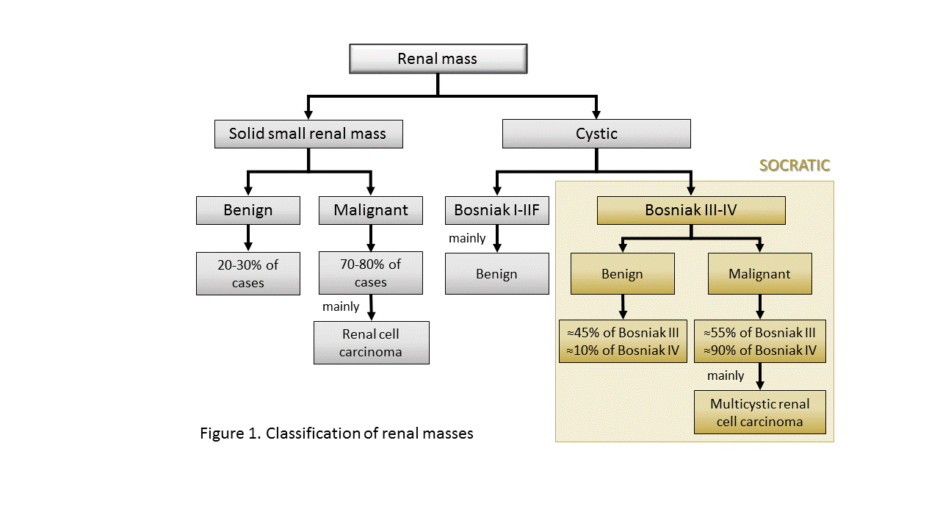
A. Problematic – With the increasing use of imaging in modern medicine, >33% of individuals aged over 60 will be diagnosed with at least one renal lesion following imaging. Indeed, kidney cancer is the 10th leading cause of cancer diagnosed in Canadians and its incidence has been rising by about 2.3% yearly. While the majority of kidney cancers are solid, between 5 to 10% of them are cystic . However, not all renal lesions are malignant (Figure 1). Cystic renal lesions are classified according to an imaging-based Bosniak classification: a 5-tier system categorizing cysts according to their degree of complexity and risk of malignancy. Briefly, Bosniak I, II and IIF cysts are mildly complex cysts with a minimal risk of malignancy. Thus, treatment is not generally recommended. In contrast, Bosniak III and IV cysts, known as complex cysts, have a higher risk of malignancy. It estimated that respectively 55% and 90% of Bosniak III and IV cysts are malignant.

B. Current management of complex cysts – Based on the current evidence and guidelines, most patients diagnosed with a complex cyst undergo surgery whom >20% will suffer various form of adverse event, including hemorrhage, urinary leakage, renal insufficiency and potentially, death . Even though this risk of malignancy might seem sufficient to justify surgery, the majority of these malignant cystic lesions have an excellent prognosis (i.e. cancer-specific survival >95-100%) and consequently, the majority of these patients will die of non-kidney cancer causes .

C. Overtreatment of complex cysts – Overtreatment occurs across all medical specialities and is likely to cause physical and psychological harm to patients. In this era of personalized medicine, willingness to involve the patient in its own treatment plan is key and the current treatment paradigm of many cancers needs to be re-examined . Even though it has often been discussed in the management of solid small renal masses, very few reports have addressed the overtreatment that arises from the current management of complex cysts. Yet, the issue of overtreatment is even greater among complex cysts given that they have a higher rate of histologically benign lesion than solid small renal masses and that even the malignant cystic lesions have a better prognosis than the solid ones.

D. The patient’s perspective – Fear related to the word “cancer” is a predominant factor influencing overtreatment. A cross-sectional survey that collated opinions from 317 participants undergoing cancer screening showed that over 80% of patients expressed their interest in being informed on potential harm of this practice. These results highlight patient’s willingness to be adequately informed and educated on their treatment options. Doing so would allow the patients to participate in elaborating the right strategy according to their own preference and not according to a “one size fits all” strategy.

E. Active surveillance – a means to decrease overtreatment – Active surveillance is a concept where treatment is delayed until there is evidence of disease progression, defined by set criteria. It involves close monitoring of a condition through tests and physical exams. This is familiar to urologists, as it is already a well-accepted management alternative for solid small renal masses. The first prospective active surveillance study for the management of solid small renal masses was reported back in 2011. This study reported a progression to metastases in only 1.1% of cases, but after only a 2-year follow-up. These findings were corroborated by the Delayed Intervention and Surveillance for Small Renal Masses registry which has prospectively reported on the 5-year outcome of active surveillance for solid small renal masses. A number of studies and meta-analyses have since confirmed the safety of this approach as well as its cost-effectiveness compared to upfront surgery. As such, based on the current evidence and in spite of the lack of randomized controlled trials, active surveillance is now recognized as a safe oncological management alternative .

Nevertheless, given the lack of data in support of active surveillance for complex cysts, all of the current guidelines, including the recently published Canadian Urological Association guidelines on the management of renal cysts, continue to recommend surgery as the mainstay treatment for complex cysts. To date, only two retrospective studies have examined the long-term outcomes of active surveillance in complex cysts. Both studies have suggested that this approach was safe, with only 1 death due to kidney cancer observed after 5 years of follow-up and with only 2 patients with a Bosniak IV cysts having developed a metastasis out of 243 patients (0.8%) – both of whom had refused surgery despite evidence of local progression.

F. Adoption of active surveillance for complex cysts – In spite of these reassuring data, a recent Canadian survey, conducted by P Richard, revealed that most urologists feel that their openness toward active surveillance is tempered by the lack of high-quality data supporting this management strategy for complex cysts. Of the 144 responders (25% response rate), nearly one third considered active surveillance a management option in most Bosniak III cyst, but only 10% did the same for Bosniak IV cyst. Interestingly, >60% of urologists felt that active surveillance was not an adequate management alternative for Bosniak IV cysts. The most common perceived barriers for a greater adoption of active surveillance were the: 1) lack of oncologic safety data; 2) lack of data on eligibility criteria for active surveillance; and 3) lack of specific triggers for discontinuation of active surveillance.

G. Summary – Overtreatment is common in uro-oncology. This phenomenon is accentuated in kidney cancers by the fact that not all lesions, solid or cystic, are actually malignant. The role of active surveillance in the management of complex cysts has seldom been studied and we believe that more of these patients could be managed by this strategy.

II. RATIONALE FOR THE PROPOSED STUDY
This study will fill the current knowledge gap in the management of complex cysts. The rationale for this study is that: 1- respectively, 45% and 10% of Bosniak III and IV cysts are histologically benign ; 2- malignant cystic lesion patients have a >95-100% cancer-specific survival after a median of 10-years postoperative follow-up; 3- malignant cystic lesions have a better cancer specific survival than malignant solid small renal lesions; 4- despite behaving more aggressively than complex cystic lesions, solid renal masses are more frequently managed by active surveillance than complex cysts; 5- well-designed prospective cohort studies on solid small renal masses have supported the role of active surveillance as a management alternative due to its proven oncologic safety; 6- active surveillance of complex cysts has been supported by two retrospective studies; and 7- adoption of active surveillance for complex cysts is impeded by a lack of data supporting its safety and guidance as to its appropriate medical conduct. As active surveillance is not standard of care practice in Canada, rigorous evidence on how best to conduct this strategy for complex cysts is required.

III. PROPOSED RESEARCH
- Research question
Does active surveillance offer a 5-year cancer-specific survival similar to surgery for patients with incidentally diagnosed complex cysts, and a minimum of 5 years of estimated life expectancy?

- Hypotheses
We hypothesize that patients under active surveillance will have a: 1- 5-year cancer-specific survival similar to those undergoing surgery; and 2- 5-year progression to treatment of <30%.

- Objectives
Primary: Compare the 5-year follow-up cancer-specific survival between the active surveillance and the surgical groups.
Secondary: a) Compare 5-year overall survival between the active surveillance and the surgical groups; b) Compare the 2-year cancer-specific survival and overall survival between the active surveillance and the surgical groups; c) Evaluate the 2- and 5-year treatment free survival for the active surveillance group and active surveillance discontinuation rate; d) Evaluate disease progression for the active surveillance group; e) Evaluate patient and tumor characteristics associated with cancer-specific death, treatment free survival and disease progression; f) Compare patient’s well-being between the active surveillance and the surgical groups; g) Compare the cost of each treatment strategy and h) assess the predictive ability of radiomics.

- Study design and study population
A multicenter observational longitudinal prospective cohort study of patients incidentally diagnosed with a Bosniak III and IV cysts, who are deemed to have at least 5 years of life, and who opted to be managed by either surgery or active surveillance.

- Study Sites
This study will take place at a minimum of 10 hospital centres: To conduct the SOCRATIC study, we have chosen sites where uro-oncologists have already embraced the active surveillance strategy.

- Eligibility
Inclusion Criteria:
a) aged ≥18 years at the time of diagnosis;
b) diagnosed with a Bosniak III (defined by a cyst wall/septum nodule (obtuse margin) ≤3mm (perpendicular axis) OR any septa ≥4mm in thickness)or Bosniak IV cyst (defined by a cyst wall/septum nodule (obtuse margin) ≥4mm (perpendicular axis) or any solid component with an acute margin of protrusion) (v.2019);
c) if present, cyst wall/septum nodule (obtuse margin) <10mm (perpendicular axis) or nodular/solid component ≤ 2cm in any axis
;
e) solid component acute margin of protrusion ≤2 cm in maximal diameter for Bosniak IV cysts;
f) life expectancy >5 years (by physician’s estimate);
g) new diagnosis of either Bosniak III or Bosniak IV (based on contrast-enhanced CT scan or MRI findings) ≤12 months from accrual date;
h) currently asymptomatic from the disease;
i) deemed fit enough for surgery;
j) willingness and ability to complete questionnaires in either French or English;
k) able and willing to provide informed consent.

Exclusion Criteria:
a) history of a hereditary renal cancer syndrome;
b) presence of polycystic kidney disease;
c) Any prior history of renal cell carcinoma;
d) received systemic therapy for another malignancy within the12 months prior to accrual
e) uncontrolled medical illness including infections, hypertension, arrhythmias, heart failure, or myocardial infarction/unstable angina within 6 months that would predispose to immediate surgical therapy;
f) metastatic disease or evidence of vascular or nodal disease;
g) unwillingness to undergo monitoring and imaging studies;
h) any contra-indication(s) to contrast-enhanced imaging (estimated glomerular filtration rate <30min/mL)

- Study outcomes
Primary: 5-year cancer-specific survival; Rationale for primary outcome: Cancer-specific survival is the most important determinant to caregivers and patients as to whether active surveillance is a safe alternative to surgery. A 5-year follow-up was estimated, by our team and other kidney cancer experts, to be a good trade-off between what is considered a satisfactory follow-up to determine patient’s safety and the feasibility of the study due to cost.
Secondary: a) 5-year overall survival; b) 2-year overall and cancer-specific survival; for the active surveillance cohort only: c) 2- and 5-year treatment free survival and active surveillance discontinuation rate; d) 2- and 5-year disease progression characterized by: mean tumor growth rate, disease progression rate and time to progression, when applicable; e) patient and tumor characteristics associated with cancer-specific death, treatment free survival and disease progression; f) quality of life and anxiety change over time (from diagnosis to end of follow-up) defined by EQ5D, SF-12 score and HADS score, g) cost of each management strategy and h) the predictive ability of radiomics

- Definition of study outcomes

- Cancer-specific survival: Defined as the time from the date of enrollment to the date where an individual experienced death from kidney cancer or censoring due to lost to follow-up or the end of follow-up period
- Overall survival: Defined as the time from the date of enrollment to the date where an individual experienced death from any causes or censoring due to lost to follow-up or the end of follow-up period.
- Treatment-free survival: Defined as the time from the date of enrollment to the date where an individual experienced a systemic treatment or a definitive intervention to managed his/her complex cyst or censoring due to lost to follow-up or the end of follow-up period.
- Active surveillance discontinuation rate: Defined as the percentage of patients on active surveillance that underwent systemic or definitive invasive treatment
- Tumor growth rate: Defined by change in volume (cm³) and change in maximal diameter measured over time (years). Volume will be calculated using the formula for ellipsoid volume: 0.5326 x length x width x height.
- Tumor progression rate: Defined as the percentage of patients with tumors that have met our pre-specified progression endpoints
- Time to tumor progression (Progression-free survival): Defined as the time from the date of enrollment to the date where an individual experienced tumor progression or censoring due to lost to follow-up or the end of follow-up period.
- Patient and tumor characteristics associated with cancer-specific death: Defined as demographic (i.e. age, sex, comorbidities, medical history, etc) and tumor characteristics (i.e. tumor size, tumor complexity, etc) associated with kidney cancer deaths.
- Patient and tumor characteristics associated with treatment free survival: Defined as demographic (i.e. age, sex, comorbidities, medical history, etc) and tumor characteristics (i.e. tumor size, tumor complexity, etc) associated with treatment free survival.
- Patient and tumor characteristics associated with disease progression: Defined as demographic (i.e. age, sex, comorbidities, medical history, etc) and tumor characteristics (i.e. tumor size, tumor complexity, etc) associated with disease progression.
- Perceived health over time: Defined as the change in EQ5D-5L scores over time (enrollment to censoring due to lost of follow-up or the end of follow-up period).
- Quality of life change over time: Defined as the change in SF-12 scores over time (enrollment to censoring due to lost of follow-up or the end of follow-up period).
- Anxiety change over time: Defined as the change in HADS scores over time (enrollment to censoring due to lost of follow-up or the end of follow-up period).
- Cost associated with each intervention: Defined as the total direct (patients) and indirect (healthcare system) cost associated with the management of a complex cyst according to each treatment strategy (active surveillance and surgery).

I) Definition of disease progression
For the purpose of the study, disease progression will be confirmed by contrast-enhanced CT-scan or MRI with the following criteria as:

a- For Bosniak III cysts:
- progression or development of cyst wall/septum nodule (obtuse margin of protrusion) >1.0cm (perpendicular axis);
- or growth of nodular component to >3 cm in any axis;
- or growth rate of cyst wall/septum nodule component >0.5cm/year (based on 3 separate imaging at least 3 months apart);

b- For Bosniak IV cysts:
- progression or development of cyst wall/septum nodule (obtuse margin of protrusion) >1.0cm (perpendicular axis);
- or growth of solid or nodular component to >3cm in any axis;
- or growth rate of solid component >0.5cm/year (based on 3 separate imaging at least 3 months apart);
c- Occurrence of metastasis; and

These definitions will be used as triggers for discontinuation, with the addition of:

d- Patient’s decision.

IV. STUDY PROCEDURES

Group allocation:
The choice of the group (active surveillance or surgery) will be done by the patients in collaboration with his/her physician. There is no randomization, nor blinded allocation in this study. The patient will choose his preferred treatment and it will be documented in the CRF. To meet the 2:1 ratio of enrollment (AS: surgery), enrollment will be competitive.

Recruitment and follow-up scheme

- Baseline visit – Upon written informed consent approval, the follow-up scheme (Figure 2) will be explained to the patients by experimented local research nurses/assistants.

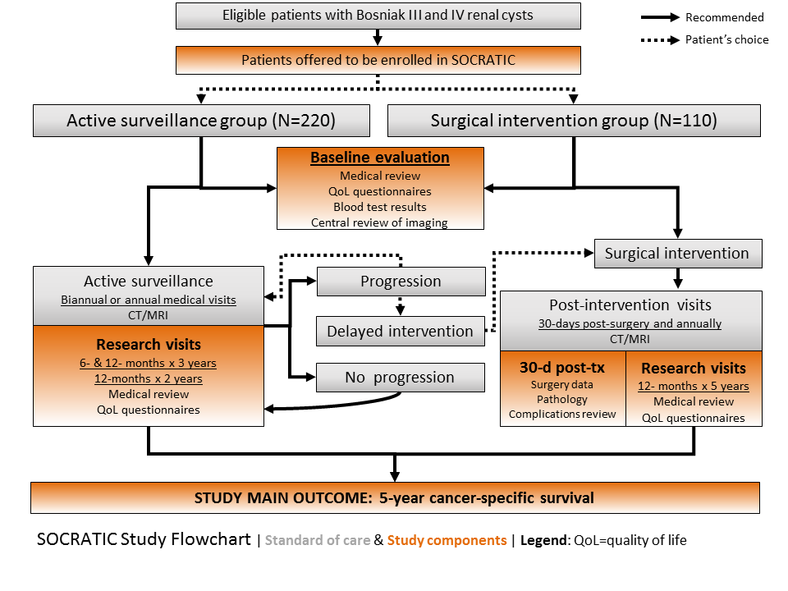
Figure 2. SOCRATIC Study Flowchart

First, the baseline visit will consist of the following items:

- blood work results as recommended by treating physicians (standard of care), but must include complete blood count, serum creatinine and urine analysis.
- socio-demographic (age, gender) and medical history data (previous cancer or renal conditions, height, weight, medication…) through patient medical chart and direct questioning of patients
- performance status evaluation (Karnofsky Performance Status Scale)
- a chest x-ray (or chest CT) and an abdominal contrast-enhanced CT scan/MRI as prescribed by treating physicians (as standard of care) to ascertain for cyst characteristics (≤12 months prior accrual)
- quality of life and anxiety/depression assessment through validated questionnaires (i.e. SF-12 and Hospital Anxiety and Depression Score (HADS) questionnaires)
- Healthcare related cost questionnaire

Blood work results and questionnaire administration should be completed within 4 weeks (±30 days) from the date of enrollment (date of signed consent). Baseline imaging should have been completed within 12 months prior the date of enrollment (date of signed consent).

- Follow-up scheme:
For active surveillance group, follow-up visits should be scheduled every 6 months (for the first 3 years) and then annually (for the last 2 years)(+/- 60 days) from the enrollment visit (date of signed consent).

For surgery group, follow-up visits should be scheduled at 1, 2, 3, 4 and 5 years (+/- 60 days) from the enrollment visit (date of signed consent).

The follow-up visits will consist of the following items:

- blood work results as recommended by treating physicians (standard of care), but must include complete blood count, serum creatinine and urine analysis (at first year only). It is also suggested to perform a serum creatinine analysis on a yearly basis.

b) quality of life and anxiety/depression assessment through validated questionnaires (i.e. SF-12 and Hospital Anxiety and Depression Score (HADS) questionnaires)
c) healthcare related cost questionnaire (every 6 months for the active surveillance group for first 3 years and then annually; annually for surgical group)
d) for patients under active surveillance: an imaging per standard of care (at least a chest x-ray (or chest CT), and abdominal contrast-enhanced CT scan/MRI once a year and CT scan/MRI or ultrasound for half year follow-ups)
e) for patients who have undergone surgery: they will be assessed 30-days after surgery for complications and will be followed on an annual basis with abdominal imaging (as per standard of care) for a total of 5 years.

During standard follow-up, if progression is suspected based on ultrasound findings, a contrast-enhanced CT scan/MRI is recommended to confirm progression. If a tumor is deemed to have progressed based on growth rate, a subsequent CT/MRI is recommended (3 months from the last one) to confirm growth rate >0.5cm/year.

Protocol specific triggers for discontinuation

Discontinuation of active surveillance will be recommended when these criteria are met:
- Progression or development of cyst wall/septum nodule (obtuse margin of protrusion) >10mm (perpendicular axis);
- Growth of solid or nodular component to > 3cm in any axis;
- c) Growth rate of solid or cyst wall/septum nodule component >5mm/year (based on 3 separate imaging at least 3 months apart)

- d) Occurrence of metastasis; and
e) Patient’s decision.

According to these pre-specified definitions, all patients meeting any of these criteria on contrast-enhanced CT-scan or MRI will be offered invasive treatment or systemic therapy. However, the decision to continue active surveillance or proceed to treatment will be left at the discretion of the patient and his/her treating physician.

Data collection
- Clinical and quality of life data
Validated questionnaires (EQ5D, SF-12 and HADS) will be self-administered by patients. The study personnel (research nurse/assistant) will collect other information on the study case report forms (CRFs) during the planned windows (see Table 1). All data collected in the study will be entered in the two web-based platforms (REDCap and CKCis) within 5 business days after collection.

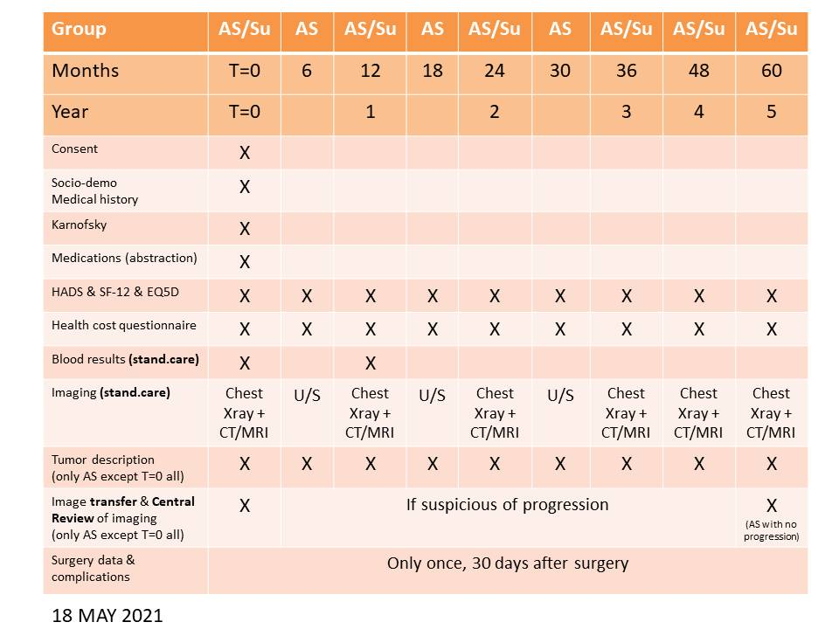
Table 1. Description of the data collection throughout the study (5 years)
Legend: AS-active surveillance; Su-surgery; CT- contrast-enhanced computerized tomography; MRI-magnetic resonance imaging; U/S-ultrasound

- Cost-associated data:

In order to compare the costs related to each strategy (active surveillance vs surgery), the healthcare related cost will be evaluated by three means:

- Direct costs incurred to patients will be evaluated by a self-administered questionnaire (every 6 months for the active surveillance group for the first 3 years and then annually; annually for the surgical group).
- Direct healthcare costs at the hospital level will be estimated using case costing information made available by each participating centres). Based on these initiatives, cost related to each management strategy (operating room, hospitalization, outpatient and emergency visits, consumables) will be estimated.
- Costs related to physicians’ salary will be evaluated indirectly based on provincial administrative databases.
- These data will be compared with responses from the EQ5D, measuring quality of life. For their part, QALYs (indirect costs related to patients’ quality of life) will be derived from the SF-12 questionnaires using the SF-6D instrument .

Imaging data and adjudication review
Baseline abdominal imaging (contrast-enhanced CT/MRI) for all participants will be reviewed centrally, by Dr Maxime Noel-Lamy (coll.), interventional-radiologist at the CIUSSSE-CHUS, to confirm Bosniak classification. The evaluation of the baseline imaging will be used to validate the patient’s eligibility to the study. The most recent imaging (CT/MRI up to 12 months prior to enrollment) should be used as the baseline imaging. The local team should upload the images within the following 7 days (after imaging or enrollment). The delay between imaging transfer and central review response should be no more than 14 days. The eligibility of the patients will be validated by a local reviewer. However, for the purpose of the standardization of the study the central reviewer will confirm the patients’ eligibility for the final analyses.

In addition, any of the most recent imaging for a patient meeting one of progression definitions will also be centrally reviewed (sites will need to upload images within 30 calendar days). In case of disagreement between the study site and central review assessment, the central review will take precedence over the recruitment center assessment. Nevertheless, the decision to pursue treatment will be left at the discretion of the patient and his/her treating physician, in which case the reason for treatment will be considered as the patient’s choice. For patients deemed not to have progressed during the study, the 5-year follow-up imaging (+/- 60 days) will also be centrally reviewed to confirm the absence of progression.

In all these situations, imagings will be shared with the central team after de-identification, through a web-based platform (Owncloud). The images will be transferred on secured Canadian servers (in Sherbrooke, QC) with unique user access for each site.

V. SAMPLE SIZE AND ANALYSIS PLAN
A. Sample size – A sample size of 300 patients, using a two-sided 95% confidence interval, will provide a predicted half-length of 5% for the cancer-specific difference between the active surveillance and surgical group at a significance level of 0.05 based on Wilson’s method, assuming a 2:1 ratio in favor of the active surveillance group and a 5-year cancer-specific survival of 95% and 98% for the active surveillance and surgical group, respectively . For a fixed total sample size, the 2:1 ratio provides a shorter predicted confidence interval than the standard 1:1 since, roughly speaking, the 5-year cancer-specific survival of the surveillance group is estimated to be less than that of the surgical group, and a ratio in favour of the active surveillance group will therefore compensate for the higher variance of its associated 5-year cancer-specific survival empirical rate. To account for a 10% lost to follow-up, the total required sample size will be 330 patients.

B. STATISTICAL ANALYSIS PLAN – Baseline characteristics will be compared using the chi-squared and Wilcoxon sum of rank tests, where appropriate. Survival analyses will also be conducted under the intention-to-treat principle, as patients transferred to a treatment option will be included. Overall survival, cancer-specific and progression-free survival will be presented using time to event analyses (Kaplan-Meier curves and/or cumulative incidence function). All survival analyses will be stratified according to Bosniak classification and management strategy. Survival outcomes between strategies will be compared using log-rank and Gray’s tests, where appropriate. Patient and tumor characteristics associated with tumor progression and death (both overall and cause-specific) will be ascertained using a competing risk model and a Cox-Proportional Hazard model adjusted for treating center clustering and for key patient (age, gender, Karnofsky performance status), treatment (surgery vs. active surveillance) and tumor characteristics (Bosniak classification, size of lesion, appearance of lesion, tumor growth rate, size of solid component and maximal thickness of septa/calcification and other analyses through radiomics). Growth rate and changes in quality of life and anxiety/depression scores will be determined using a functional data approach accounting for time dependencies in the repeated measures. Descriptive statistics will be used to present progression rates, when applicable. The economic analysis will be based on an incremental cost-effectiveness ratio (ICER) to estimate the relative cost-utility (cost per QALY) of the two strategies. To estimate the confidence interval on the difference in direct medical cost and in QALY, we will perform non-parametric analyses with 5,000 bootstrap replications. We will also perform cost-effectiveness acceptability curves (CEAC) to compare the cost-effectiveness thresholds for different cost per unit gains. An annual 1.5% discount rate will be considered.

VI. STUDY MANAGEMENT

Study supervision
The study will be supervised by the Executive committee (led by Dr Patrick Richard, Antonio Finelli, Philippe Violette, Gordon Guyatt and the project leader) who will develop and implement study procedures and will follow on the study compliance.

The steering committee will take part in the major decisions regarding the study orientations. This committee will include each site lead from each participating center, the study statistician, the patient partner(s), specific experts (radiology and health-cost analysis) and a representative of KCC/KCRNC.

Study central coordination
The Unité de Recherche Clinique et Épidémiologique (URCE) is a clinical academic research hub at the CHUS Research Center. The URCE will take the lead in terms of study coordination across the participating centres. The URCE will be involved in: 1) launching pre-study activities (REB, SOPs, study tools, training); 2) study and budget management (agreements, central revision coordination; site fee payments); 3) planning investigators’ meetings; 4) securing site initiation visits, monitoring and closeout activities; 5) ensuring co-development of the REDCap database with the CRED and CKCis database with Kidney Cancer Research Network of Canada; 6) enrollment and retention reports; 7) planning knowledge transfer activities. To help them in these tasks, the URCE has engaged patient-partners for this project in order to include patient perspective at each step of the process.

Data management
Clinical and medical data will be collected using paper case report forms (CRF), after questioning the patient or abstracting the medical records. Since patients may be co-enrolled in SOCRATIC and in the CKCis registry, common data to both studies will be entered only once, in the CKCis database. Therefore, data unique toSOCRATIC will be entered on a web-based electronic CRF (eCRF) called REDCap. All data should be entered within 5 business days of collection. A standard operating procedure manual will ensure uniform data collection and local staff will be trained to ensure standardization across sites. Remote data monitoring will be used under a risk-based approach and on-site monitoring will occur when needed.
The REDCap database allows electronic data capture, multi-user connexion and provides a module for trail audit. The data are hosted on secured servers at the CRCHUS and administered by the CRED Unit, which undergoes an annual external audit and are certified ISO 27001.The CRED has 20 years’ experience in data management and will develop the eCRF with data quality algorithms and queries in order to ensure data quality.
For its part, CKCis is a web-based database whose central server resides at a secured location at the University Health Network (UHN) Princess Margaret Cancer Centre in Toronto. The database is maintained by a team at UHN including an implementation specialist, a system administrator and a support analyst. This team works in conjunction with the Steering and Operations Committees of CKCis to ensure that data security is maintained and that database updates and data validation are completed in a timely and accurate fashion.
For both REDCap and CKCis, patients enrolled in SOCRATIC will only be identifiable through a unique identification number. A log of nominative patient information will be kept under lock at each site. Only the treating doctor, the local research team and their delegated data entry person will have access to this information, except if a breach to security occurs. If there is a security breach the local privacy office, the CKCis and SOCRATIC Steering Committees will be advised of this occurrence. Corrective measures will be taken in a timely manner. Each participating site should comply with provincial and local regulations regarding retention times and destruction procedures for data kept at their site. Patient logs will be archived at each site for 10 years following the last data entry from that centre.

Ethic issues
As this study is observational, we do not expect any particular issues that will prevent its conduct. Active surveillance is a recognized management option according to the Canadian Urological Association guidelines for select cases of complex cysts. The treating physician at each site will have the responsibility to discuss the risks and benefits of each treatment strategy with the patients . To help the physician in conducting a standard discussion with all their patients, a one-pager summary will be provided to them with both risks and benefits of each strategy, according to the latest scientific literature.

Each participating site will be responsible to obtain their Institutional Research Board approval. However, if a multi-center process is in place (such as in the province of Quebec where the study will be evaluated and approved by the Comité d’éthique à la recherche of the CIUSSS Estrie-CHUS in Sherbrooke), one center may be designated as the evaluating REB. Sites will also be accountable for their institutional feasibility approval, which is mandated to formalize collaboration with the hospital services/departments (for instance, radiologists for imaging transfer, archives for costs assessment, when applicable).

Clinical Trial Registration
To reduce publication biases and fulfill journal requirements, the study is registered in a public registry on www.clinicaltrials.gov.

Incidental findings
If an incidental finding arises from a research analysis conducted during the study (following imaging review, mostly), the corresponding site lead will first evaluate the clinical significance of this finding and act on it based on the patient’s best interest. Disclosure of incidental findings to the patient will rely on the local treating team that has access to the medical chart, the patient’s medical history and all other images. Since some of the imaging reading for the study will be batch read at the end of the study (5-year imaging), first local reader conclusions will stand as the truth standard for clinical management, unless an incidental finding was completely missed. In this case, the local site lead and treating physician will be contacted.

Patient Safety
With its observational design, this study is very unlikely to report adverse events or serious adverse events. Although some of these complex cysts are benign and even though the malignant ones are generally considered indolent and of low-metastatic potential , active surveillance patients will be at risk of disease progression. However, progression is already included as a study outcome and the treating physician or the patient can opt for definitive treatment at any point during follow-up. Accordingly, patients in the active surveillance group will be closely monitored by their treating physician and any progression (i.e. surgery, local progression or development of metastasis) will be reported to the coordinating center within 30 calendar days. Additionally, to maximise patient’s safety, an internal monitoring will be conducted to review data integrity, specific outcomes related to safety. Periodic statistics (enrollment rate, retention rate and progression rate) will be reported to the executive committee for discussion.

VII. EXPECTED RESULTS & PERSPECTIVES
Expected Results
For the primary objective, we expect that the 5-year cancer-specific survival difference between patients managed by active surveillance and upfront surgery will be no greater than 5%.
For the secondary objectives, we expect: a) that most deaths to be caused by diseases other than kidney cancer; and b) a high 2-year cancer-specific survival in both groups. For the active surveillance group, we expect: c) a growth rate ˂0.3cm/y and a progression to treatment of <30%; d) that the presence of a wall/septum nodularity at baseline and the size of the solid component will be the only factors associated with tumor progression; e) that quality of life scores will be maintained throughout the study period and that anxiety scores will be low and comparable to the surgical group; f) that active surveillance will be a more cost-effective strategy than surgery; g) radiomic analyses will help predict which tumor is benign/malignant.

Perspectives
Very likely both active surveillance and surgery are potentially reasonable choices with different harms and benefits for a given patient. In this context patient values and preferences are paramount. Our study will provide the necessary data to develop decisions aids to facilitate shared decision-making. Furthermore, increased use of active surveillance, if supported by our results will also lead to diminished interventions. Consequently, this study has the potential to spare thousands of patients from unnecessary interventions (and their complications), which will potentially lead to decreased healthcare costs. Importantly, following the 5-year follow-up period, patients recruited to our study in one of the Canadian Kidney Cancer Information System (CKCis) participating centers will continue to be prospectively followed. Through CKCis, these patients will be followed-up until death or lost to follow-up thus gathering important information on the cohort long after the grant has ended.

VIII. REFERENCES
(References from the research team are indicated in bold)

